Happily
Ever After’s
Don’t Just Happen

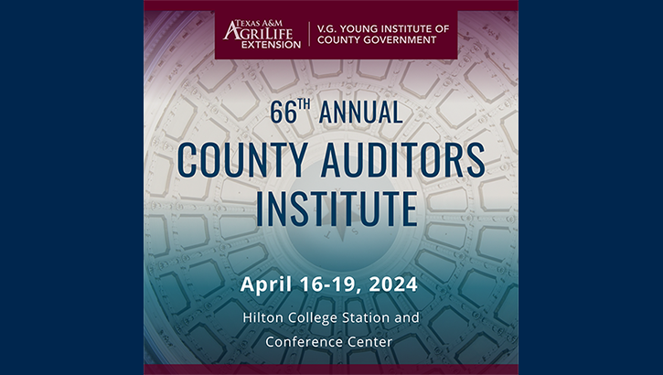

The "Happily Ever After Cycle"

New & Exciting
("H.E.A.")

    

Looking New Wears Off

 

Just Give Up Denial

 

Blame Fear

             

Anger

How Leadership Skills are Developed
In the Real World

- Progressively

- Some Success & Some Failure

- A Little Theory; Lots of Effort

- From the Inside-Out

Progressively

- Achieving success is a process, not an event

- The “New” ears off most processes before they produce the results being sought

- Effective leaders persevere beyond the point at which “The New Wears Off”

Some Success & Some Failure

Success & failure will characterize
your efforts to improve your leadershiop skills

Your commitment to doing so is best measured
by your responses to your failures

- Some of life’s greatest gifts come disguised as failures

- Anything worth doing is worth doing _____________

A Little Theory; LOTS of Effort

- You can easily find information on ways to improve your leadership skills

- Applying that information to leadership challenbges you encounter is something only you can do

From the Inside-Out

- Leadership is a 2-dimensional discipline
- Mechanical – the things leaders say and do

- Mental – the mental choices leaders make and the emotional consequences those choices produce

- The hands you’re dealt do matter

- The choices you make about the hands you’re dealt—especially the mental choices—matter more!

The Rule

You ______________ the quality of your days

Application

To have exceptional days, stop looking for ___________________________to The Rule

Because …

_____________ ________ _______ ________________________________________ to The Rule

